## **Skin Disease Detection**

Submit automated predictions of disease classification within dermoscopic images.

Pick any 5 disease categories (from the drive; each folder is a disease category). Examples of possible disease categories are:

## Nevus

## Melanoma

## Pigmented Bowen’s

## Vascular

## Basal Cell Carcinoma

Drive link:

<https://drive.google.com/drive/folders/1WZ87gunaKF5EIxNb4j8sHI7xiY7uM-Hl?usp=sharing>

Download the ‘Skin_conditions” folder locally and you will see the different disease categories.

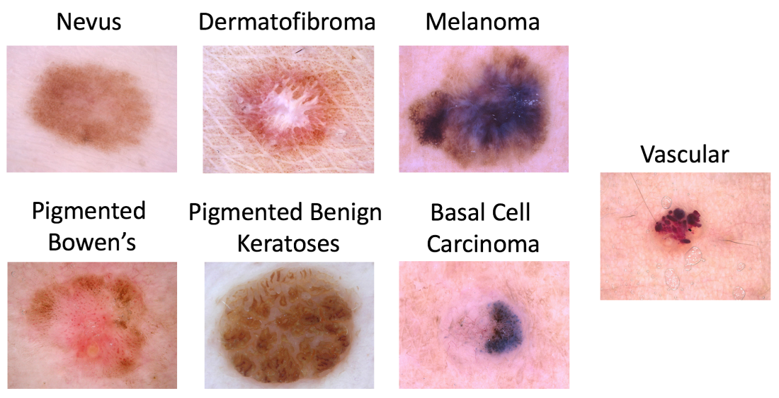

## **Data**

### Input Data

The input data are dermoscopic lesion images in JPEG format. All lesion images are named using the scheme “Disease_name_id .jpg”. The skin disease images for a variety of [dermatoscope types](https://dermoscopedia.org/Principles_of_dermoscopy), from all anatomic sites from Google and Medical Books. Images were reviewed by Skin specialists.

## **Submission Instructions**

To participate in this task:

1. Train
   1. Download the training input data and training ground truth response data.
   2. Develop an algorithm for generating Disease Lable in general.
2. Validate (optional)
   1. Download the validation input data.
   2. Run your algorithm on the validation Input data to produce validation predicted responses.
   3. Submit this validation predicted responses to receive an immediate score. This will provide feedback that your predicted responses have the correct data format and have reasonable performance. You may make unlimited submissions.
3. Test
   1. Download the test input data.
   2. Run your algorithm on the test input data to produce test predicted responses.
   3. Submit this test predicted responses. You may make up to 5 submissions, but only the most recent submission for each approach will be used for official judging.
   4. Submit a manuscript describing your algorithm’s approach.

## **Evaluation**

### Goal Metric

Get the top 5 Predicted responses for each image and check if the actual Disease Label is one of the predicted responses.

Other possible things to explore (not part of project evaluation)

### Other Metrics

Participants will be ranked and awards granted based only on the multiclass accuracy metric. However, for scientific completeness, predicted responses will also have the following metrics computed (comparing prediction vs. ground truth) for each image:

#### Individual Category Metrics

* [sensitivity](https://en.wikipedia.org/wiki/Sensitivity_and_specificity#Sensitivity)
* [specificity](https://en.wikipedia.org/wiki/Sensitivity_and_specificity#Specificity)
* [accuracy](https://en.wikipedia.org/wiki/Accuracy_and_precision#In_binary_classification)
* [area under the receiver operating characteristic curve (AUC)](https://en.wikipedia.org/wiki/Receiver_operating_characteristic#Area_under_the_curve)
* [mean average precision](http://fastml.com/what-you-wanted-to-know-about-mean-average-precision/)
* [F1 score](https://en.wikipedia.org/wiki/F1_score)
* AUC integrated between 80% to 100% sensitivity (AUC80) for Melanoma diagnosis only
* [positive predictive value (PPV)](https://en.wikipedia.org/wiki/Positive_and_negative_predictive_values)
* [negative predictive value (NPV)](https://en.wikipedia.org/wiki/Positive_and_negative_predictive_values)

##### Aggregate Metrics

* average AUC across all diagnoses